Freeflight weekend in Norway , at frozen lake Mjosa.
We plan to run two World Cups 4th.and 5th.March 2023.
Eagle Cup on Saturday and Danish Winter Cup at Sunday, with Monday 6th.as
reserve day for remaining rounds and flyoff.
The headquarters will be at Hovdetun Youth hostel in Gjovik. The organizer will be there
Friday from18:00-20:00 for registration and Entry fee. The Entry fee is 35 Euro, juniors 15 Euro.
We intend to fly F1A-B-Q with 4 min. max in round 1 and 2, if we have calm weather.D
Due to early sunset , first flyoff is 8 min. max.( If possible.)
We will run the competitions according to Sporting Code, with these exceptions:
There will be 5 rounds before flyoff, and we go direct to 8min.max in first flyoff, because of early sunset. There will be no official timekeepers. The participants time each others in groups. In flyoff we all need to help other classes to time flights.
Flying site. We will find a place between Lillehammer and Gjovik, with the best conditions on ice.
It can be cold (in the morning),slippery and some snow, so be prepared. We will have some battery drills you can borrow to place your equvipment.
There will be a Briefing before the start of the first round. Competitors are urged to form groups of 3 persons who are timing each others. Scorecards must be handed over to the CD after each round into tent.
We must help timing each classes at flyoff. All who qualifies to the flyoff must bring a timekeeper,
then the organizer make a draw of who will be your timekeeper.
If flyoff not finish before dark at first contest on Saturday, it will be held on Sunday morning before the next contest starts or Monday morning. If the winner are not found before sunset on Sunday world Cup, there will be flyoff Monday morning.
Price giving will be at Hovdetun together with Dinner, hopefully Saturday and Sunday.
Price giving Monday will be on the ice.
More details will be given at our Facebook: Ørnen modellflyklubb
Accommodation can be made to following places:
Hovdetun Vandrerhjem : HI Gjøvik Hovdetun pfhone: +47 61 17 10 11 mail: post@hovdetun.no
Bed and breakfast pr. person/day 55Euro Dinner evening 18 Euro. Prices at Hovdetun freeflighters.
Dinner must be order the day before, because delivered with a Catering. Common dinner Saturday 19:00
Quality Hotel Strand : www.nordicchoicehotels.no pfhone: +47 61 13 20 00
Vertshuset V- E6 AS: Pfhone :+47 61 18 58 00 Near horse track lane and flying site.
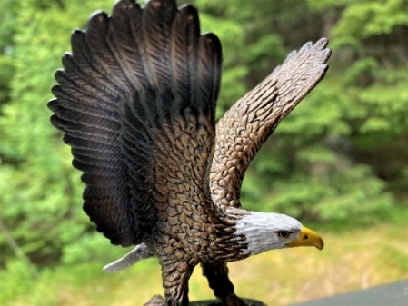 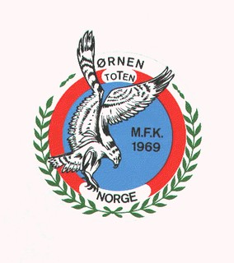
Registration/Entry Vegar Nereng, vnereng@online.no

